***Lab 2 Networking* (5%) & Journal Wiki 2 (2.5%)**

***W24 OSM620, section: cc***

***Lohan vaddepally, 150115236,***

*I declare that the attached assessment is wholly my own work in accordance with Seneca Academic Policy. No part of this assignment has been copied manually or electronically from any other source (including web sites) or distributed to other students.*

**Section 1: Lab 2 Networking (5%)**

***Part 1: Check TCP/IP Configurations on Server 1:***

**srv1tcpipconfig.jpg**

***Part 2: Use IPConfig and Ping on Server 1:***

**srv1tcpipconfigcmd.jpg**

**Where did this TCP/IP configuration come from?**

It came from DHCP. we have enabled DHCP, so it automatically assigns the Ip address from the loop of addresses.

**How do you know?**

I have checked the server1 network properties, in that DHCP is enabled.

**srv1ipconfigallcmd.jpg**

**What is the Host Name?**

Srv1-150115236

**What is the IP address of your DHCP server?**

192.168.254.254

**What is the IP address of your DNS server?**

192.168.254.2

**srv1ipconfighelpcmd.jpg**

**Explain what you have just done?**

**Ipconfig/release**

I have given the command ipconfig/release. So it releases all matching connections/releases the IPv4 address for the specified adapter.

**Ipconfig/renew**

Renew the IPv4 address for the specified adapter/renew all adapters.

**srv1ipconfigallafterrelease.jpg**

***Is* your configuration information the same as it was before or is it different? Why or why not?**

The configuration information was same. The configuration information remains the same or changes depends on the availability of a DHCP server and the success of the renewal process. If the system is using static IP addresses, the configuration will remain the same regardless of these commands.

***Why might you “release and renew” your IP configuration?***

Releasing and renewing your IP configuration can be necessary in various situations to troubleshoot network connectivity issues or to ensure that your device has a valid and updated IP address configuration.

**srv1P2pingx3.jpg**

**Is there any difference in the output of the 3 commands you used? Why or why not?** No. In terms of functionality and outcome, all three commands are essentially testing connectivity to the local loopback interface. Therefore, they should produce the same result if the loopback interface is functioning correctly.

***Part 3: Demonstrate a NAT Network* subheading:**

|  | **SRV1** | **SRV2** | **Win10** | **Host** |
| --- | --- | --- | --- | --- |
| **Property** | **Value** | **Value** | **Value** | **Value** |
| **Host Name** | SRV1-150115236 | SRV2-150115236 | W10lohanvcc | Lohan-PC |
| **Ethernet Adapter Name** | Ethernet0 | Ethernet0 | Ethernet0 | HOME |
| **Physical Address** | 00-0C-29-22-FE-A7 | 00-0C-29-17-0B-BD | 00-0C-29-CD-81-48 | 00-41-0E-98-48-D5 |
| **IP Address** | 192.168.254.130 | 192.168.254.131 | 192.168.254.129 | 192.168.254.139 |
| **Subnet Mask** | 255.255.255.0 | 255.255.255.0 | 255.255.255.0 | 255.255.255.0 |
| **Default Gateway** | 192.168.254.2 | 192.168.254.2 | 192.168.254.2 | 192.168.2.1 |
| **DHCP Server** | 192.168.254.254 | 192.169.254.254 | 192.168.254.254 | 192.168.2.1 |
| **DNS Server** | 192.168.254.2 | 192.168.254.2 | 192.168.254.2 | 192.168.2.1 |
| **Lease Obtained** | SAT, FEB10 24, 11:27:27 AM | SAT, FEB 10 24, 11:35:07 AM | SAT, FEB10,24, 2:19:54PM | FEB9 24, 9:17:03 PM |
| **Lease Expires** | SAT, FEB 10 24, 11:57:27 AM | SAT, FEB 10 24, 12:05:00 PM | SAT, FEB10,24, 2:49:54 PM | FEB12 24, 9:17:03 PM |

**nathostloopbacktest.jpg**

**# Testing the Connection from windows10:**

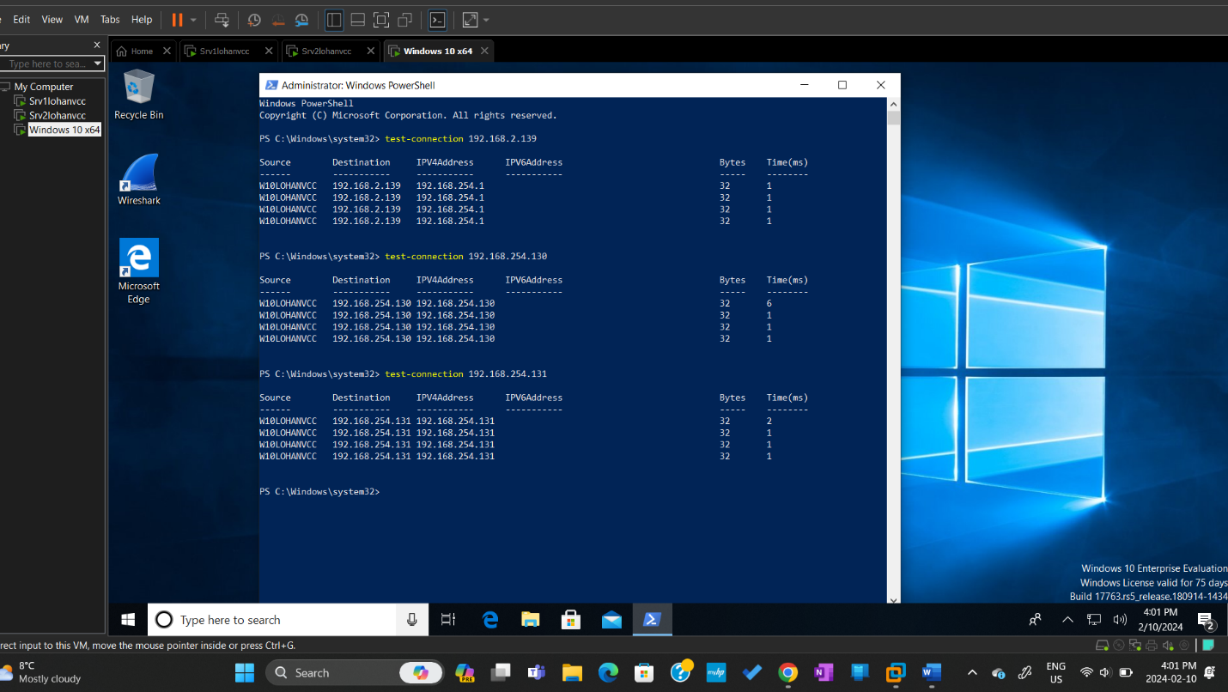

**win10testconnectionsnat.jpg**

**# Testing the Connection from svr1:**

**svr1testconnectionsnat.jpg**

**# Testing the Connection from svr2:**

**srv2testconnectionsnat.jpg**

**# Testing the Connection from svr1 using default gateway address:**

**srv1todefaultgatewaynat.jpg**

**# Testing the Connection from win10 to favorite website:**

**win10togoogle.comnat.jpg**

***Part 4: Demonstrate a Bridged Network:***

|  | **SRV1** | **SRV2** | **Win10** | **Host** |
| --- | --- | --- | --- | --- |
| **Property** | **Value** | **Value** | **Value** | **Value** |
| **Host Name** | Srv1-150115236 | SRV2-150115236 | W10lohancc | Lohan - PC |
| **Ethernet Adapter Name** | Ethernet0 | Ethernet0 | Home | HOME |
| **Physical Address** | 00-0C-29-22-FE-A7 | 00-0C-29-17-0B-BD | 00-0C-29-CD-81-48 | 0-41-0E-98-48-D5 |
| **IP Address** | 192.168.2.152 | 192.168.2.153 | 192.168.2.154 | 192.168.2.139 |
| **Subnet Mask** | 255.255.255.0 | 255.255.255.0 | 255.255.255.0 | 255.255.255.0 |
| **Default Gateway** | 192.168.2.1 | 192.168.2.1 | 192.168.2.1 | 192.168.2.1 |
| **DHCP Server** | 192.168.2.1 | 192.168.2.1 | 192.168.2.1 | 192.168.2.1 |
| **DNS Server** | 192.168.2.1 | 192.168.2.1 | 192.168.2.1 | 192.168.2.1 |
| **Lease Obtained** | SAT, FEB10 24, 2:54:14 PM | SAT, FEB 10, 24, 3:05:51 PM | SAT, FEB 10,24, 612:09 PM | FEB 9, 24, 9:17:03 PM |
| **Lease Expires** | TUE, FEB 13,24, 2:54:05 PM | TUE, FEB 13,24, 3:05:42 PM | TUE, FEB 13, 24, 6:12:09 PM | FEB 12, 24, 9:17:03 PM |

**srv2towin10testconnectivitybridged.jpg**

**srv2todefaulttgatewaybridged.jpg**

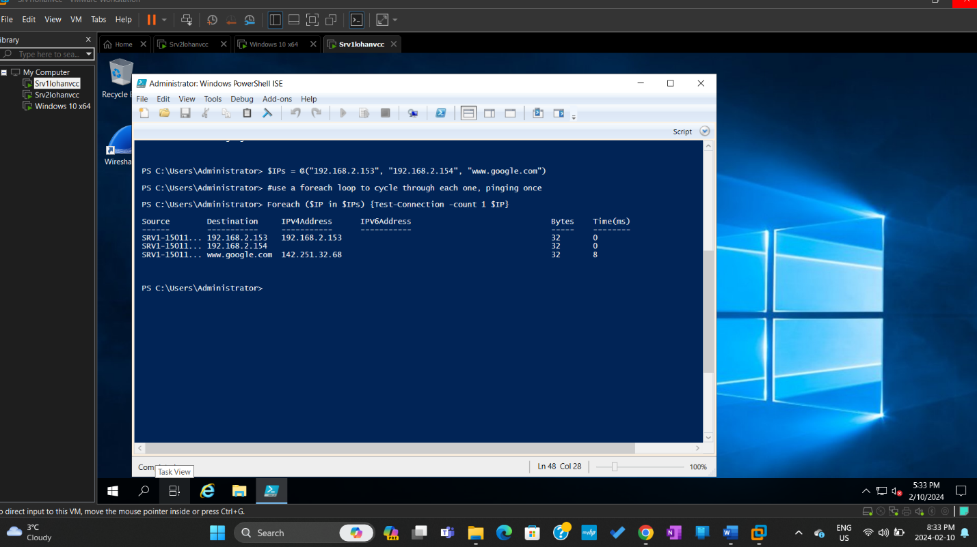

**powershellISEscriptLab2fromsvr1.jpg**

**Section 2: Journal Wiki 2 (2.5%)**

1. Examine the results of the two tables above and using your knowledge of the types of network modes in a virtual environment (NAT & Bridged), answer the following question:
   1. Have you observed any differences in the IP addresses in the different network modes (NAT vs Bridged). Explain the differences and include what the IP addresses in each network mode mean?

Ans:

Yes, The IP addresses are different. In first table we used NAT as a network mode. When a network is set to NAT mode, the router or gateway device responsible for connecting the local network to the internet translates the private IP addresses of the devices within the local network to a single public IP address before forwarding data packets to the internet. This allows devices within the local network to communicate with resources on the internet without each needing its own public IP address.

In the second table we used Bridged as a network mode. Bridged network mode is a configuration option in networking that allows a virtual machine (VM) or a container to appear as a separate physical device on the network. When you configure a virtual machine or container to use bridged networking, it essentially becomes a peer to other devices on the same network segment.

1. What were some issues/problems you had while completing this lab and how did you solve each? Include web links, if necessary

Ans:

I had faced issues with configuring the VM’s, But I was able to configure them properly and give correct IP data to each VM.

1. Include a reflection of at least 3 things that you learnt from doing the lab

Ans:

* 1. Learnt about using NAT and Bridged network modes.
  2. How test-connection is done.
  3. Troubleshoot errors and constructing PowerShell scripts.

1. What 2 things would you like to know more about?

Ans:

* 1. More about using PowerShell as a script.
  2. How connectivity works on private and public networks.

1. Include some links to good and relevant information for the lab and indicate why?

Ans:

<https://learn.microsoft.com/en-us/windows-server/get-started/get-started-with-windows-server> - tells us about how to go about windows servers.

<https://www.redhat.com/sysadmin/troubleshooting-guides-2022> - Tells about troubleshooting errors and problems in OS.